# Implementation of Google Map in Qlikview

### Introduction about Google Map:

Google Map is a web mapping service application and technology provided by Google.

In the following steps we’re going to discuss how to implement the Google Maps in Qlikview.

Google Maps and Google Earth use can be integrated in Qlikview to interpret the data at map level. For that we are using the KML, or "Keyhole Markup Language", which is a special variant of XML. It's named in tribute to the first geo-tracking satellites.

We can store information on a location in Google Earth (it will eventually trickle down to Google Maps) by using this Markup to GeoCode its specific latitude and longitude coordinates.

### Steps:

1. Loading the base data along with the Google map data(Latitude and Longitude).
2. Declare Google Map Variables.
3. Create Chart and configure for Google Map Image.

# 1.0 Loading the base data along with the Google map data

In this example, I am choosing data source as Excel and having in a location as mentioned in the screenshot below.

### 1.1 Load the base data from the Excel file:

The following steps are too explanatory, if you are good in loading data from Excel file into Qlikview, please skip this step and go directly to step 1.2.

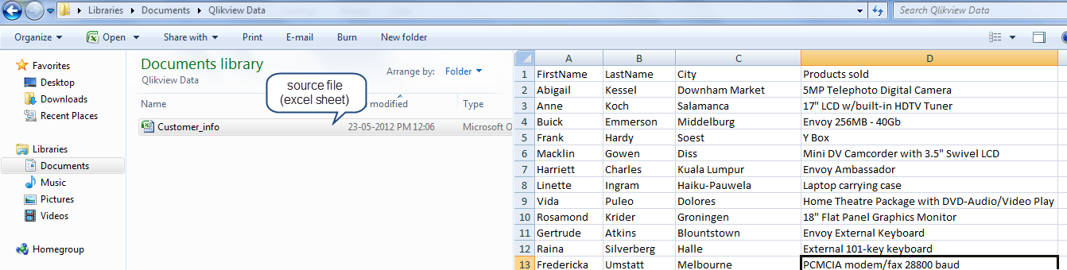

Now Open the Qlikview application by double clicking on the Qlikview icon from the desktop or selecting from the Start menu of the Computer.

Qlikview application opens.

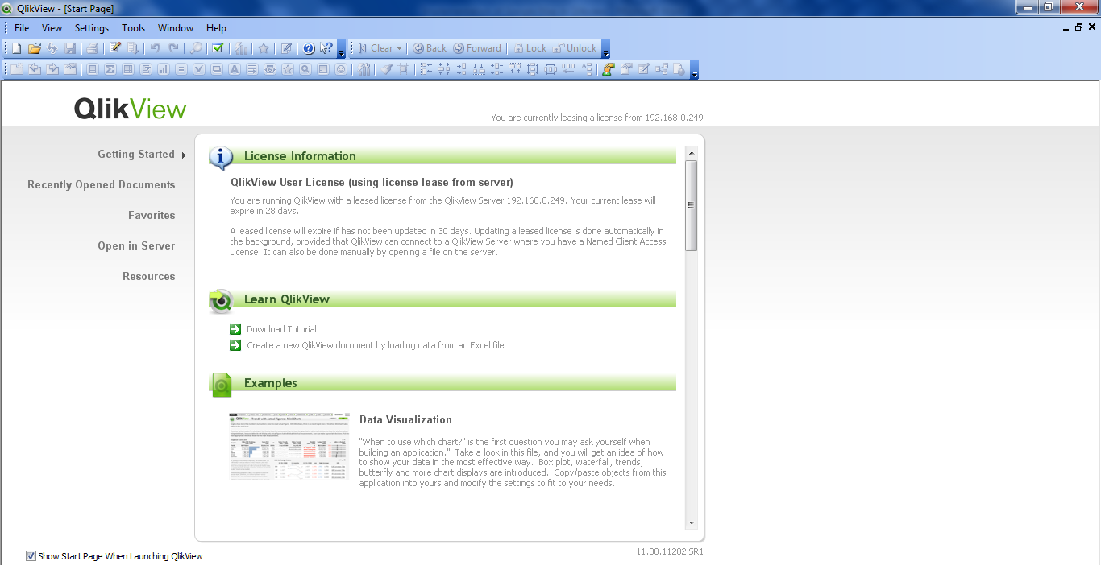

Click on File menu on the Qlikview Start Page and click New.

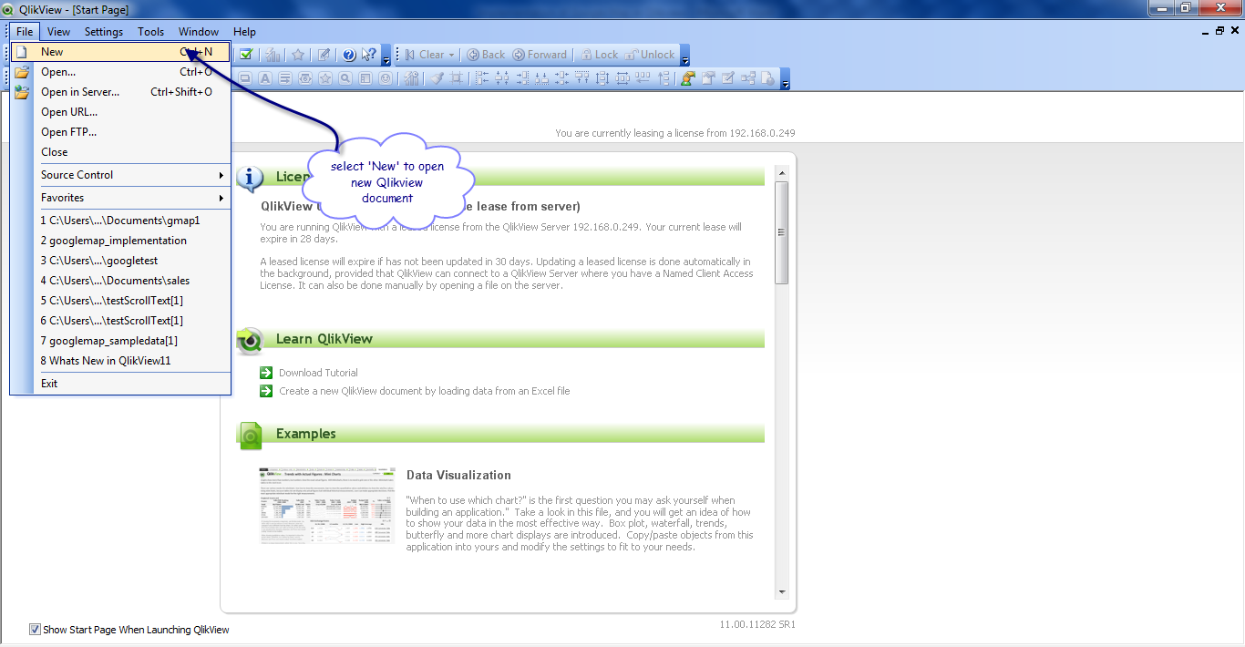

Now, a new window will opens and prompts you to select the Data Source. Click the ‘Browse’ button to select the Data Source.

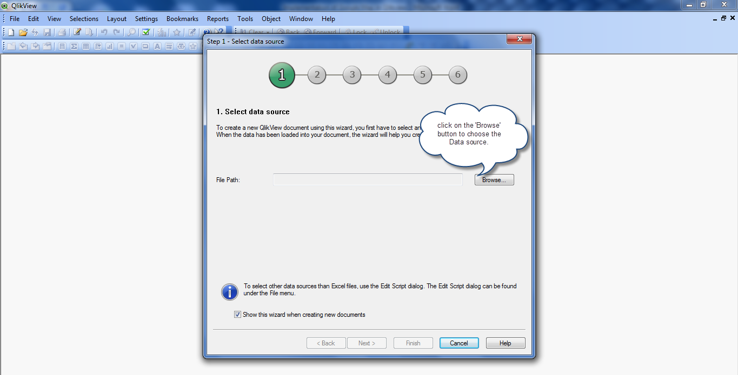

Navigate to the location in the computer where you have the source file and then select it.

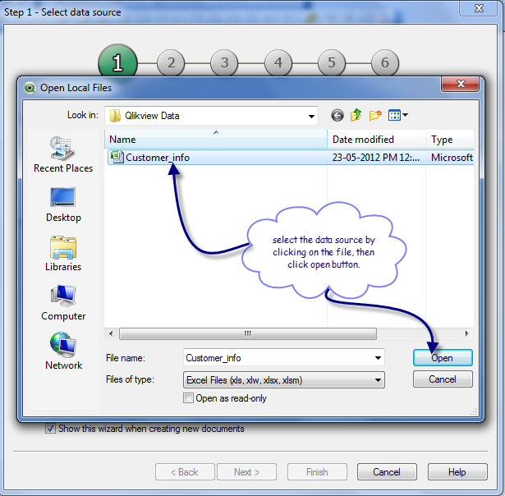

The file path will be added to the Data Source window as shown in the screenshot below.

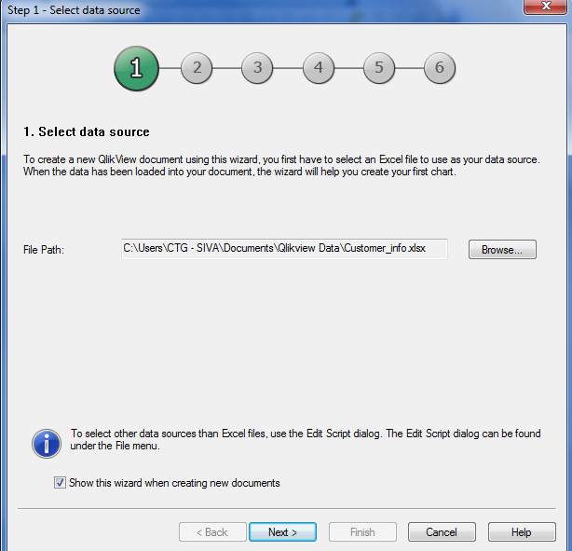

Click Next button.

‘Verify Data Presentation’ window will appears showing the data in the file. You have the options to use the first field as Column Header or you can add your own column name by renaming it. In this example, we have chosen the first option.

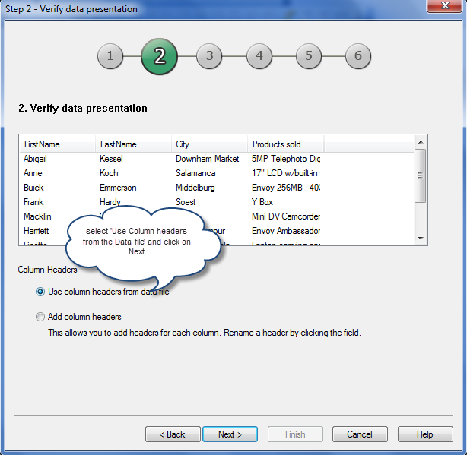

After selecting the option, click on Next.

The Next window asks to save the Qlikview file. Provide a name and click on save it .

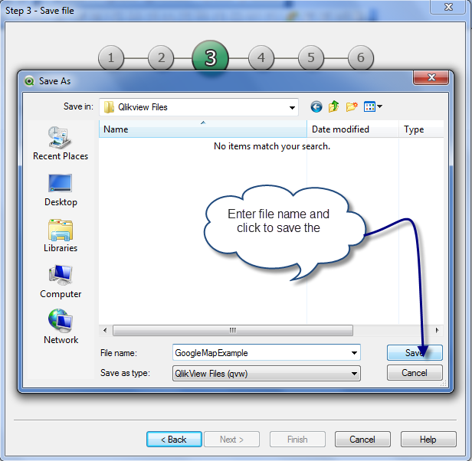

The path of qlikview file location will show as mentioned in the screenshot below.

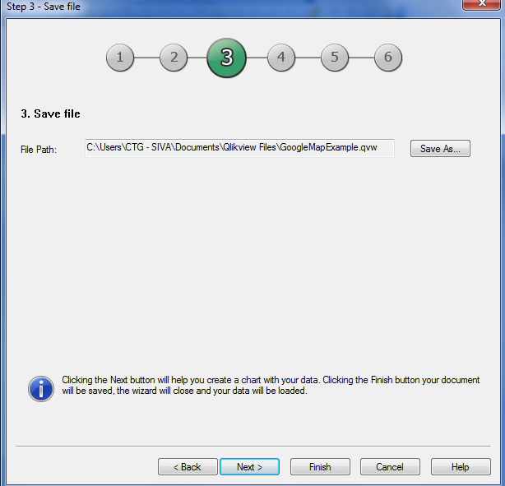

Click ‘Finish’ to finish the process of loading source data.

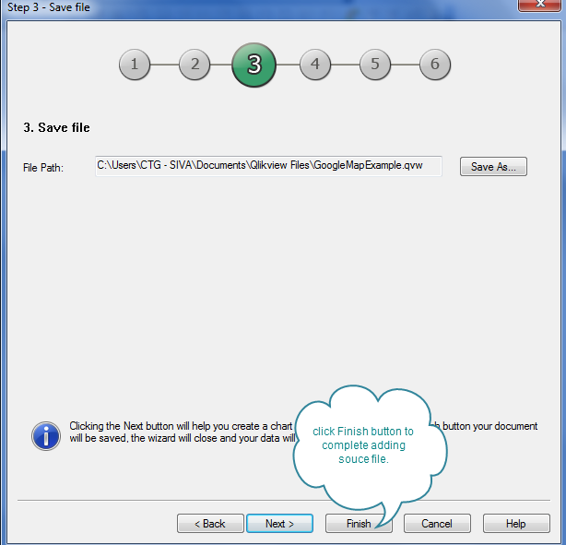

Click on the ‘Edit Script’ button to see the script for file load.

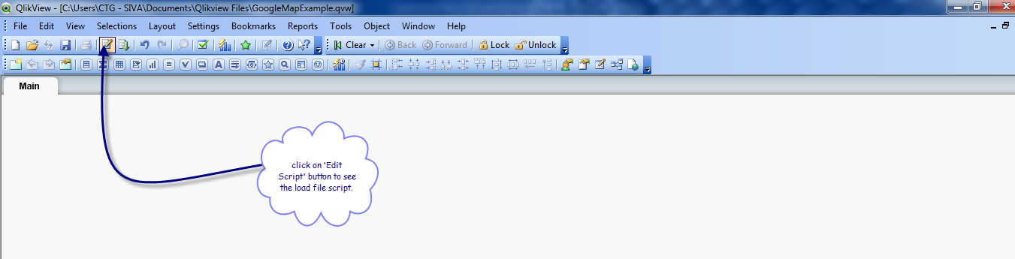

The file load script will be added automatically once the file is loaded successfully. Click on Ok button at the bottom of the screen.

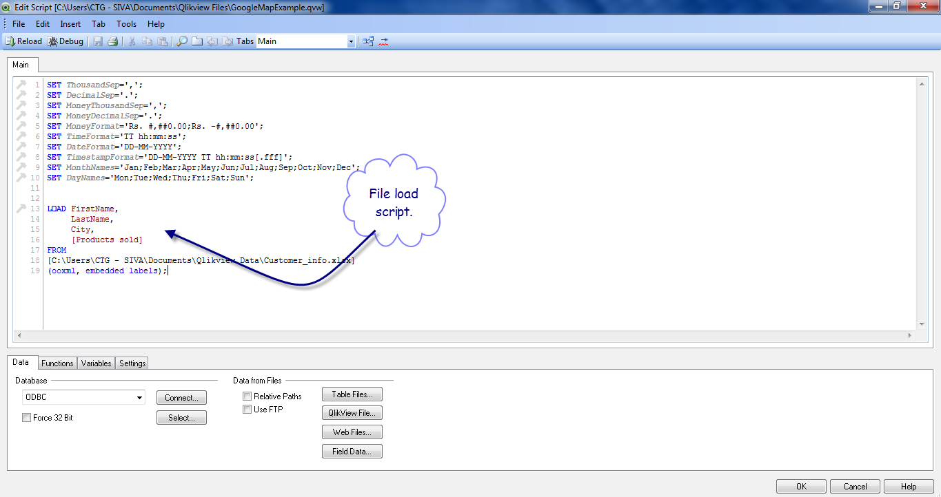

### 1.2 Load the Google map data.

In order to add two more columns longitude and latitude from the Google Map web as source we have to modify and do changes in the script as detailed below.

Please add the following code in the Edit Script window. In the following code, the city field is passed as address to the web URL which loads the latitude and longitude values for each city in the table 1 and loads the data.

**let** ***noRows*** = NoOfRows('Table1')-1;  
  
**for** ***i***=0 to ***$(noRows)***  
  
 **let** ***a***=peek('FirstName',***$(i)***,'Table1');  
 **let** ***b***=peek('LastName',***$(i)***,'Table1');  
 **let** ***c***=peek(‘ProductSold’,***$(i)***,'Table1');  
 **let** ***address***=peek('City',***$(i)***,'Table1');   
   
  
Data:  
 **LOAD**  
 '$(a)' as FirstName,  
 '$(b)' as LastName,  
 '$(c)' as ProductSold,  
 '$(address)' as Address,  
 subfield([Response/Placemark/Point/coordinates], ',' ,1) AS longitude,  
 subfield([Response/Placemark/Point/coordinates], ',' ,2) AS latitude  
 FROM [http://maps.google.com/maps/geo?q=$(address)&output=xml&oe=utf8&sensor=false&key=XXYYZZ] (XmlSimple, Table is [kml]);  
  
**next**

### 2.0 Declare Google Map Variables.

To declare Google Map Variables, create another tab in the script section.

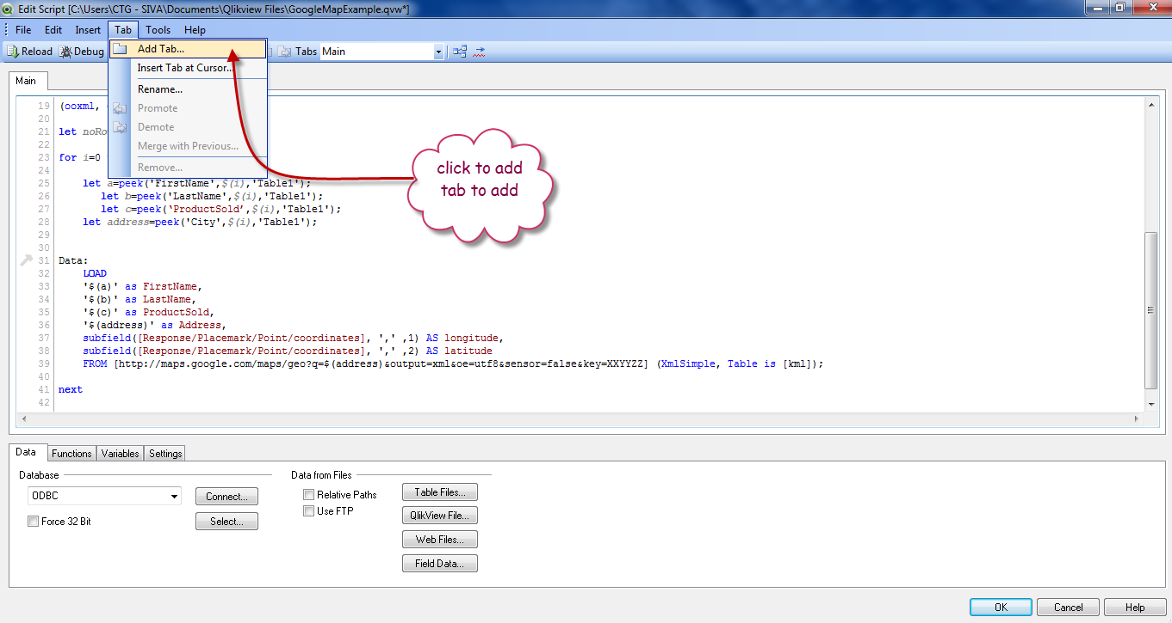

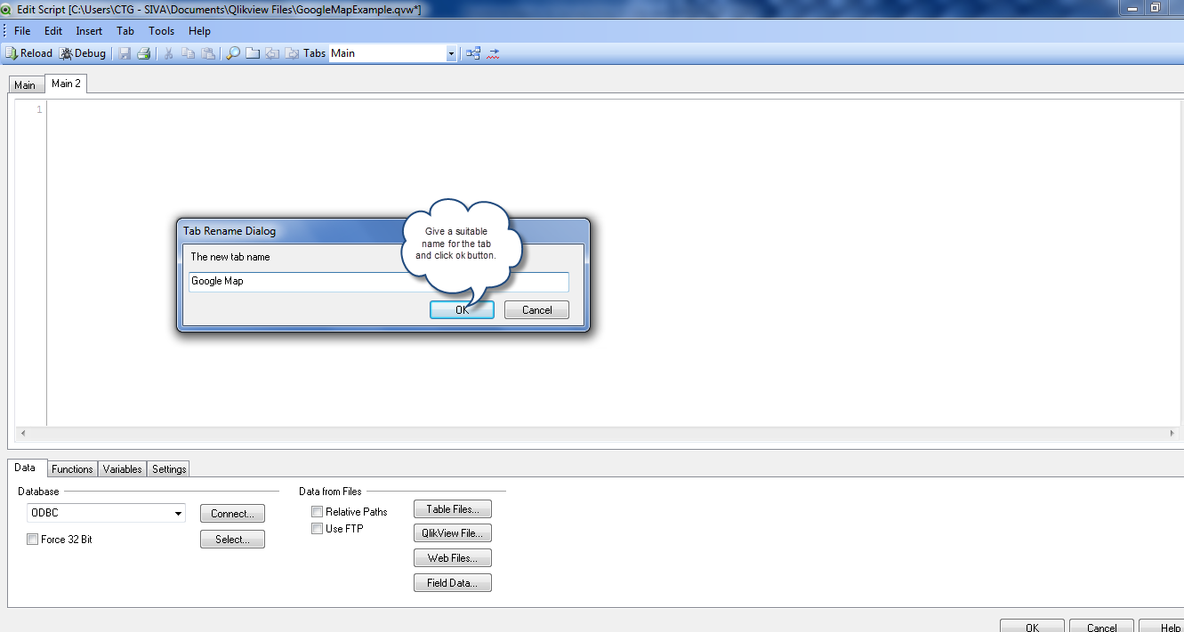

Copy and paste the following code which is for Google Map variable declaration.

// Google Maps in QlikView  
// V0.85.2 - October 1st 2008 © Copyright QlikTech International AB 2008 / AES  
  
// Google Maps Key  
// get a key here http://code.google.com/apis/maps/signup.html  
***gmap_key*** = 'xx';  
***max_zoom_level*** = 17; //maximum value 17   
  
// Variables required for calculating map  
// No need to change these  
***var_pi180***= '=pi()/180';  
***var_lat_offset***= '0';  
***var_mc2***= '=256*pow(2,$(var_zoom))';  
***var_mc1***= '=256*pow(2,($(var_zoom)-1))';  
***var_mid_lat***= '=min(latitude)+(1+var_lat_offset)*((max(latitude)-min(latitude))/2)';  
***var_mid_long***= '=min(longitude)+(max(longitude)-min(longitude))/2';  
***var_zoom***= '=max(aggr(if(max( round(256*pow(2,(_zoom_level -1)))+( longitude *((256*pow(2,_zoom_level ))/360)) )-min( round(256*pow(2,(_zoom_level -1)))+( longitude *((256*pow(2,_zoom_level ))/360)) ) <map_size_x AND max((256*pow(2,(_zoom_level-1)))+((0.5*log((1+(sin((latitude)*pi()/180)))/(1-(sin((latitude)*pi()/180)))))*((-256*pow(2,_zoom_level))/(2*pi()))))-min((256*pow(2,(_zoom_level-1)))+((0.5*log((1+(sin((latitude)*pi()/180)))/(1-(sin((latitude)*pi()/180)))))*((-256*pow(2,_zoom_level))/(2*pi()))))<map_size_y,_zoom_level,1),_zoom_level))';  
***var_maptype***= '=if(isnull(only(maptype)),fieldvalue( '&chr(39)&'maptype'&chr(39)&', 1 ),maptype)';  
***map_size_x***= '400';  
***map_size_y***= '400';  
  
**SET** ***HidePrefix***='_' ;  
// Field required for calcualting best zoom level  
_zoom_level:  
**Load** RecNo( ) as _zoom_level autogenerate(max_zoom_level);  
  
maptype:  
**LOAD** * INLINE [  
 maptype  
 roadmap  
 mobile  
 satellite  
 terrain  
 hybrid   
];

After pasting the code click save button and click ‘ok’ to close the Window.

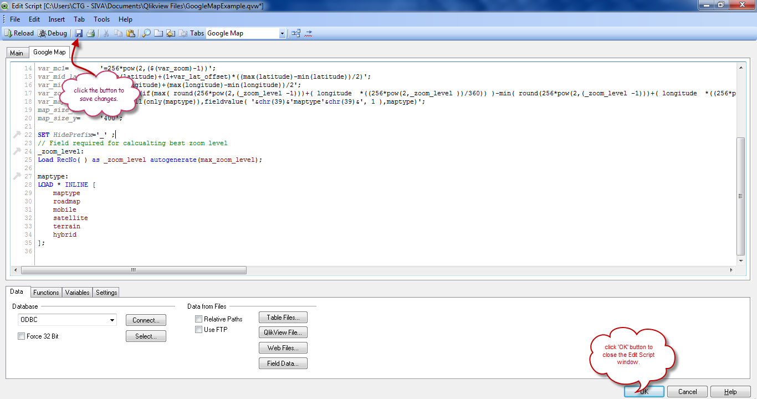

Once the script is done, click on ‘Reload’ button to load the data.

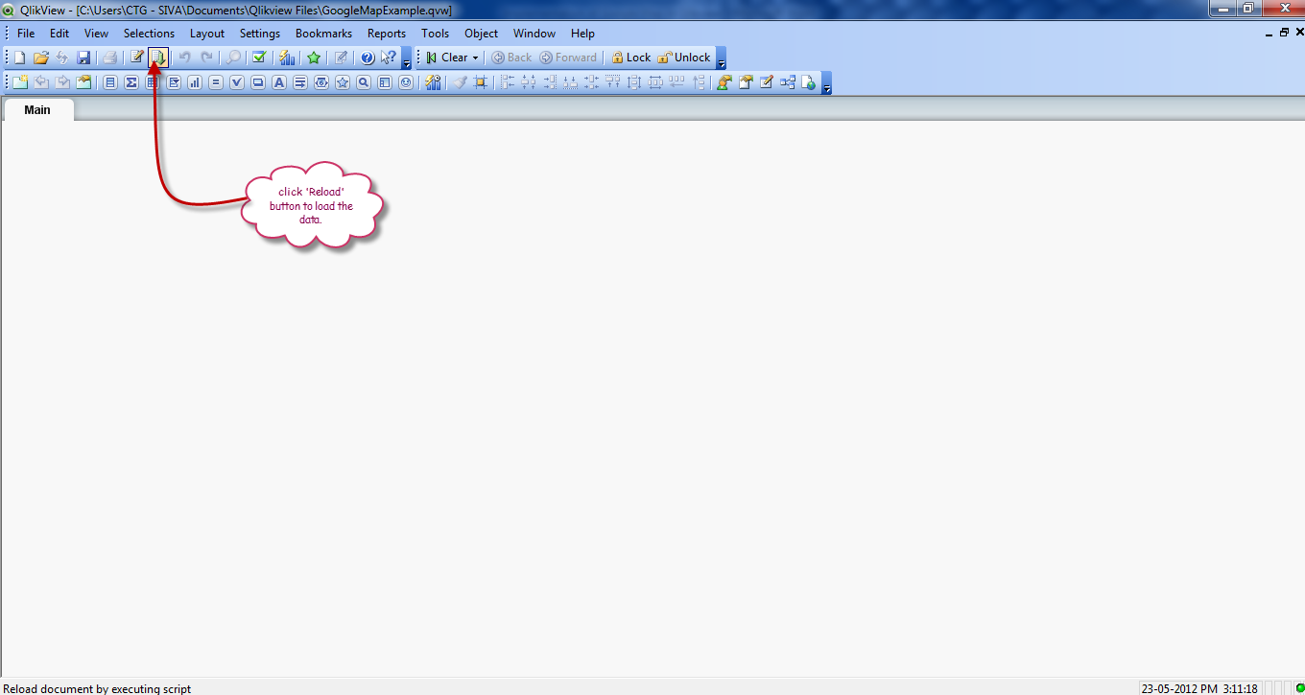

Script Execution window will open and shows the status of the data loading.

Once the data is loaded click ‘Close’ button to close the Window.

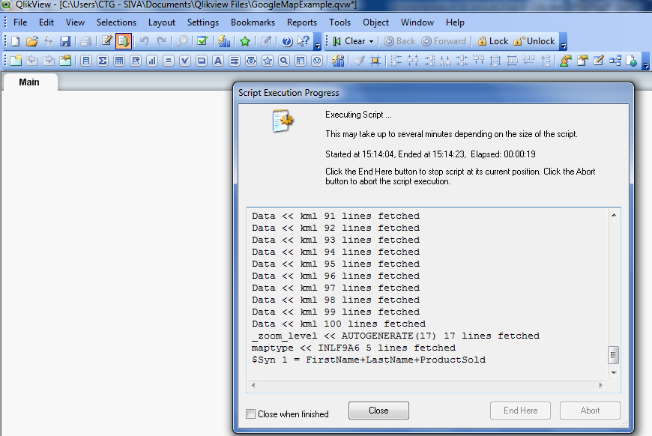

The Data is loaded successfully now. To view the data, select the desired fields from the Layout tab as mentioned in the screenshot below.

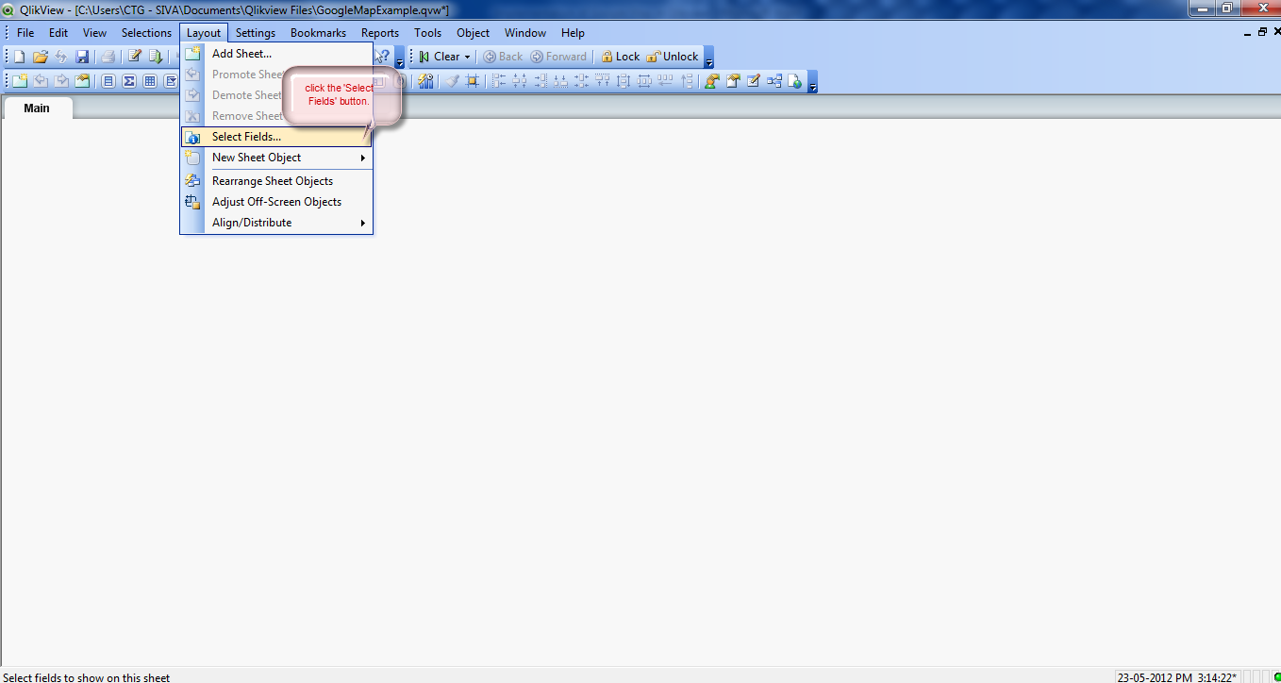

So far we have added to source and retrieved the data and re-arranged the fields in a readable format.

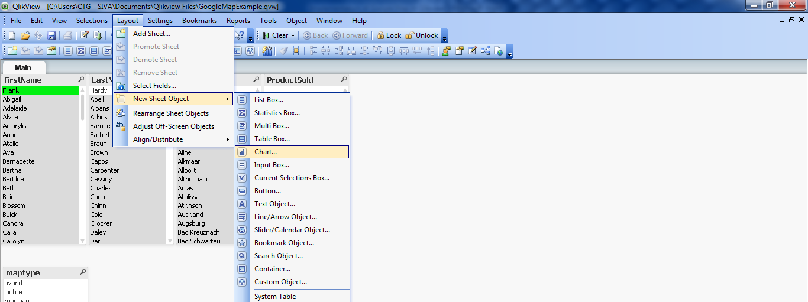

# 3.0Create Chart (for Google Image) in Qlikview:

Next step is to create two charts, one to use Google map image and the scatter chart to plot the places of the countries/cities in the map. After creating two charts, place the scatter chart over the image chart.

### 3.1 Create Google Map Chart (for Google Image) in Qlikview:

To create chart, click on ‘Layout’, ‘New Sheet Object’ and click ‘Chart’ .



General tab for creation of chart will open. Follow the below mentioned instructions to create the Google Chart.

In the General tab, select straight table and click Next,

In the Dimensions tab, click ‘Add Calculated Dimensions’ and give value ‘=1’.

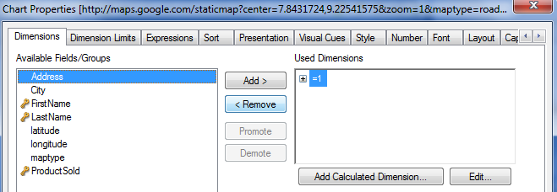

In the Expressions tab,

click add the expression and add the following code

**='http://maps.google.com/staticmap?center='  
&  
*var_mid_lat*  
&  
','  
&  
*var_mid_long*  
&  
'&zoom=$(var_zoom)'  
&  
'&maptype='&*var_maptype*  
&  
'&size=400x400'  
&  
'&key='&*gmap_key* & '.jpg'**

Select ‘No Total’ option in the Total Mode.

Select representation as ‘Image’ and Image formatting as ’No stretch’

Enable ‘Hide Text when Image Missing’.

Disable ‘Allow Interactive Sort’ option.

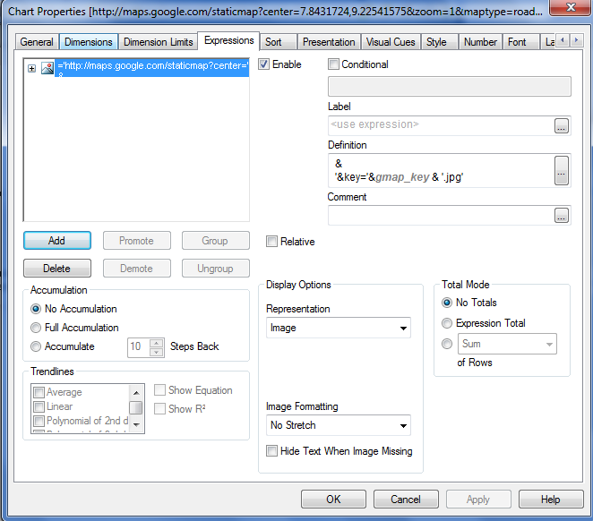

In the Sort tab, leave the default values and click Next.

In the Presentation tab,

Enable Hide column option.

Enable ‘Suppress Header Row ‘option.

Under Multiple settings, enable ‘Wrap Cell Text’ option and increase Cell Height to 30

In the visual cues tab, leave the default and click next.

Under style, select the current style as ‘Basic’.

In the Number tab, leave the default values and click next.

In the Font tab, leave the default values and click next.

In the Layout tab,

Under Layer, select option ‘Bottom’

Under Show, enable ‘Conditional’ option and add the expression as below.

if(qlikviewversion()<8.5,1,0)

Under Scrollbar, enable ‘Preserve Scroll option’.

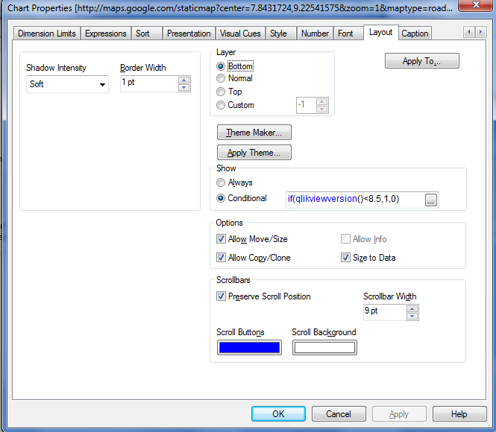

In the Caption tab,

Disable ‘Show Caption’ option and for background colour in this example chosen is dark blue colour.

Make the text colour as white.

Set the Xpos values as 234 and Width 418

Set the Ypos values as 85 and width 451.

Finally click ‘Finish’ button to complete the Chart for Google Image.

The Google Image will appear as shown below in the Qlikview.

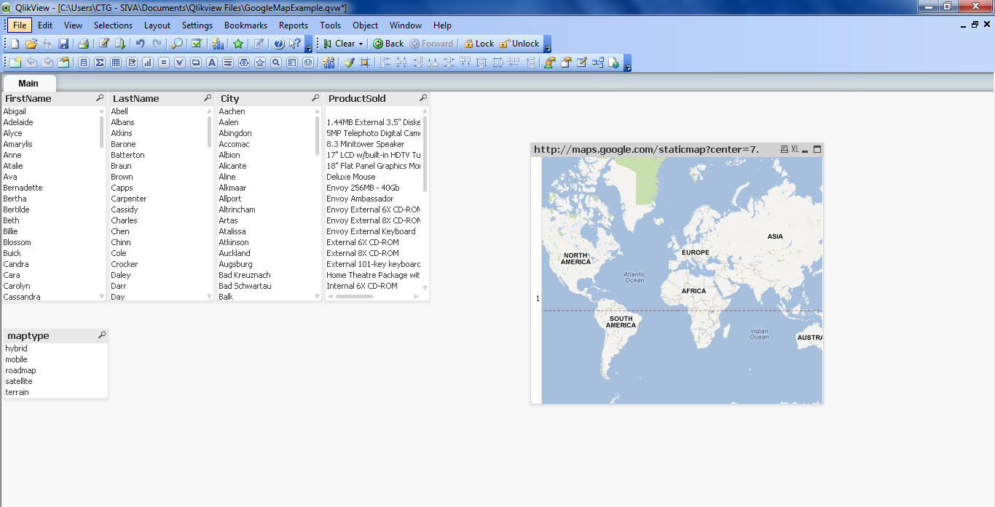

### 3.2 To Create the Scatter Chart to Plot:

Now, create the scatter chart to plot the locations.

To create chart, click on ‘Layout’, ‘New Sheet Object’ and click ‘Chart’.

In the General tab, select ‘Scatter chart’ option.

In the Dimension tab, select ‘First Name’ and click Add.

In the Expressions tab,

Add the First name, Latitude, and Longitude.

Click Latitude and in the definitions add the following expression,

=sum(   
((256*pow(2,(***$(var_zoom)***-1)))+((0.5*log((1+(sin((latitude)*pi()/180)))/(1-(sin((latitude)*pi()/180)))))*((-256*pow(2,***$(var_zoom)***))/(2*pi()))))  
)

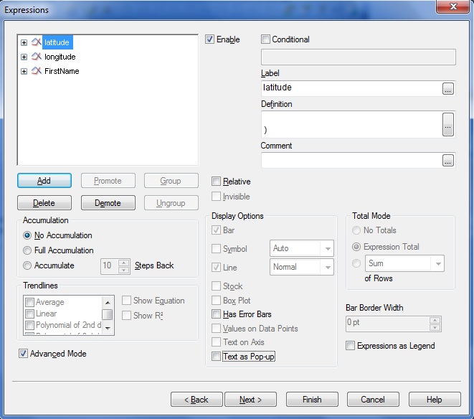

Click the Longitude and in the definitions, add the following expression,

=sum( round (256*pow(2,(***$(var_zoom)***-1)))+( longitude *((256*pow(2,***$(var_zoom)***))/360)) )

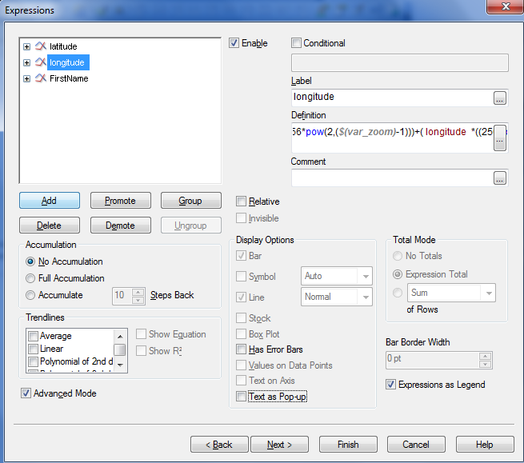

Click the FirstName and in the definitions add ‘FirstName’ from the drop down.

Enable ‘Text as Pop’ option.

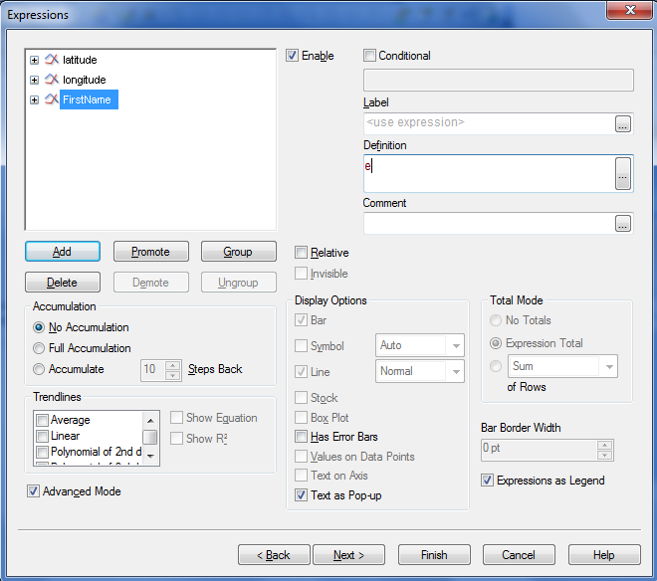

In the Sort tab, leave the default values and click Next.

In the Style tab, under look option, first option in the select the second column.

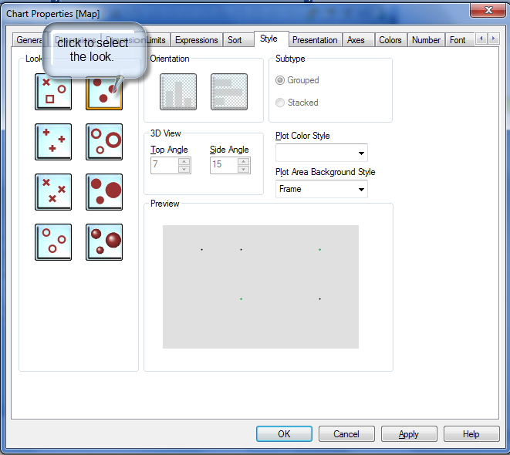

In the presentation tab, disable the ‘Legend’ option and uncheck the Show X-Label and Show Y Label.

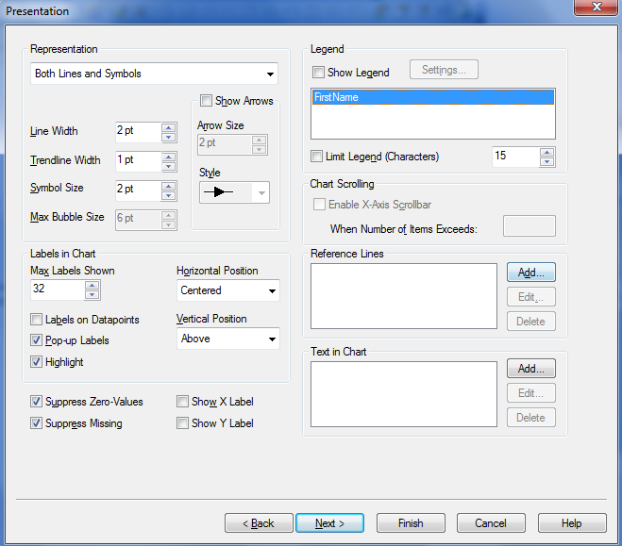

In the Axes tab, do the changes as mentioned in the screenshot below.

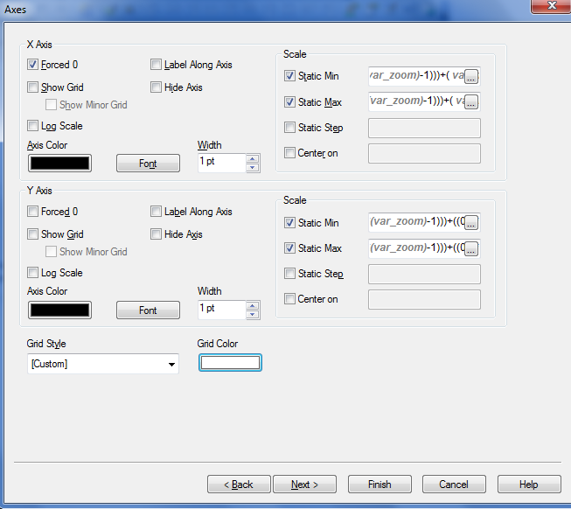

For X-Axis, Scale Static Min, add the following in the expression

(256*pow(2,(***$(var_zoom)***-1)))+( ***var_mid_long*** *((256*pow(2,***$(var_zoom)***))/360)) -round(***map_size_x***/2)

For X-Axis, Scale Static Max, add the following in the expression

**(**(256*pow(2,(***$(var_zoom)***-1)))+( ***var_mid_long*** *((256*pow(2,***$(var_zoom)***))/360)) + round(***map_size_x***/2)**)**

For Y-Axis, Scale Static Min, add the following in the expression

=((256*pow(2,(***$(var_zoom)***-1)))+((0.5*log((1+(sin(***var_mid_lat***\*pi()/180)))/(1-(sin(***var_mid_lat***\*pi()/180)))))*((-256*pow(2,***$(var_zoom)***))/(2*pi())))+round(***map_size_y***/2))

For Y-Axis, Scale Static Max, add the following in the expression

=((256*pow(2,(***$(var_zoom)***-1)))+((0.5*log((1+(sin(***var_mid_lat***\*pi()/180)))/(1-(sin(***var_mid_lat***\*pi()/180)))))*((-256*pow(2,***$(var_zoom)***))/(2*pi())))-round(***map_size_y***/2))

In the Colour tab, do the changes as mentioned in the screenshot below.

For Dynamic Image, paste the URL

='http://maps.google.com/staticmap?center='  
&  
num(***var_mid_lat***, '##############', '.', ',' )   
&  
','  
&  
num(***var_mid_long***, '##############', '.', ',' )   
&  
'&zoom=$(var_zoom)'  
&  
'&size='&***map_size_x***&'x'&***map_size_y***  
&  
'&key='&***gmap_key***   
&  
'&maptype='&***var_maptype***  
& '.jpg'

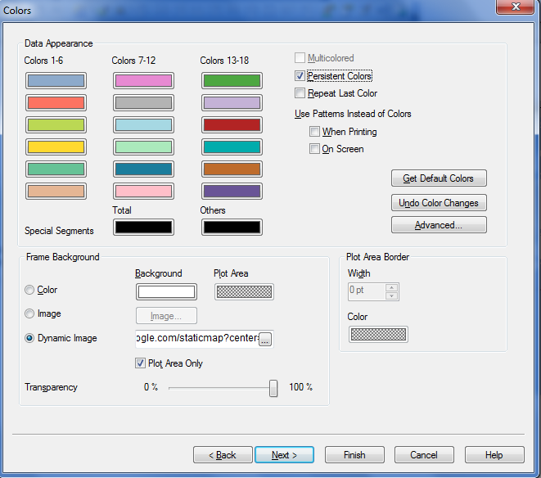

In the Number tab, leave the default values and click Next.

In the Font tab, leave the default values and click Next.

In the Layout tab, do the settings as mentioned in the screenshot below.

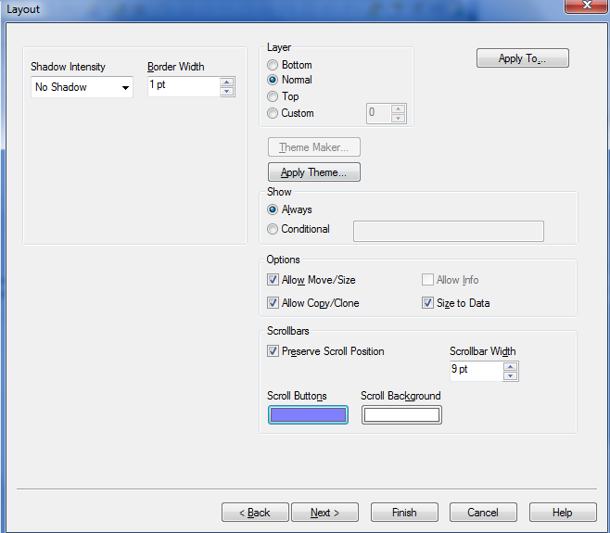

In the Caption tab, do the following settings as mentioned in the screenshot below.

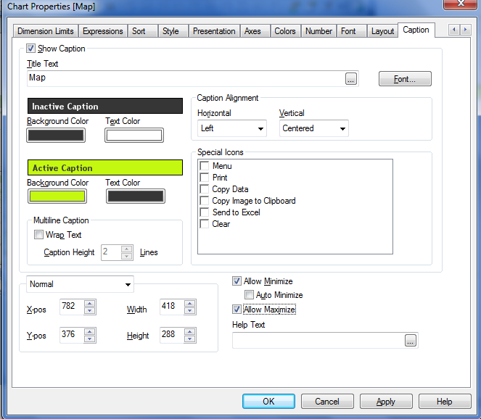

Click Apply and click ok to close the window. Now drag the scatter chart over the Google Map.

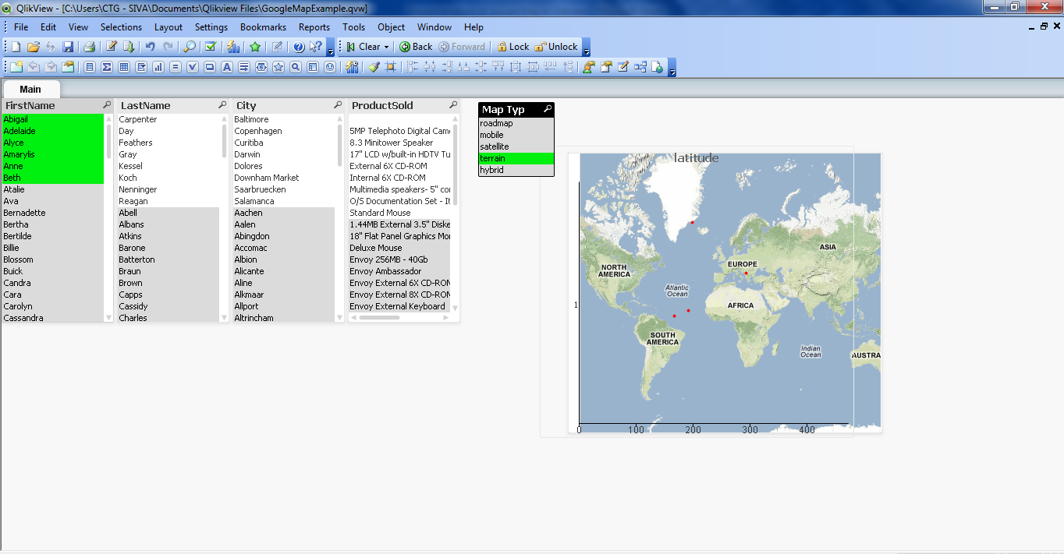

Clicking on the names in the List box will show the customer location in the Google Map.

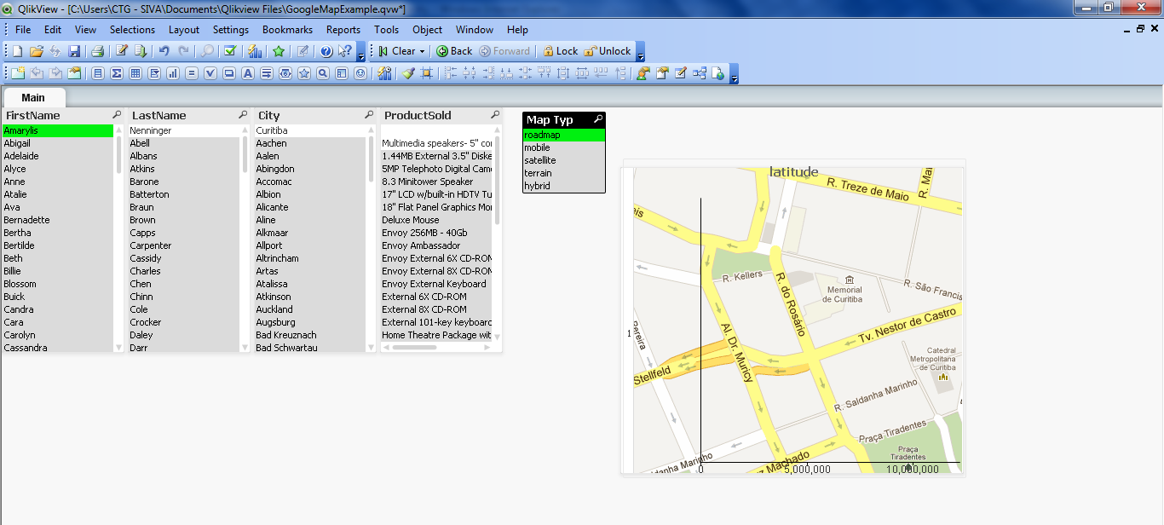

You can select the Map type such as Mobile,Satellite,Hybrid and view the location.

Note. You can also copy the Chart and paste it in your document and configure.